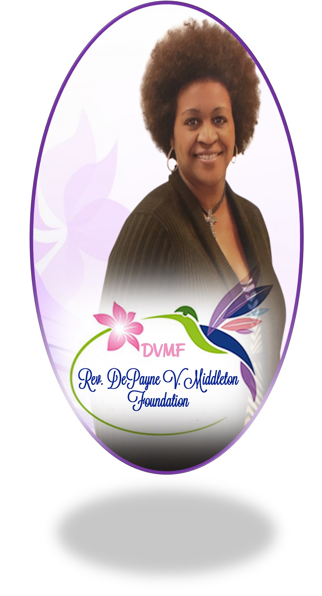
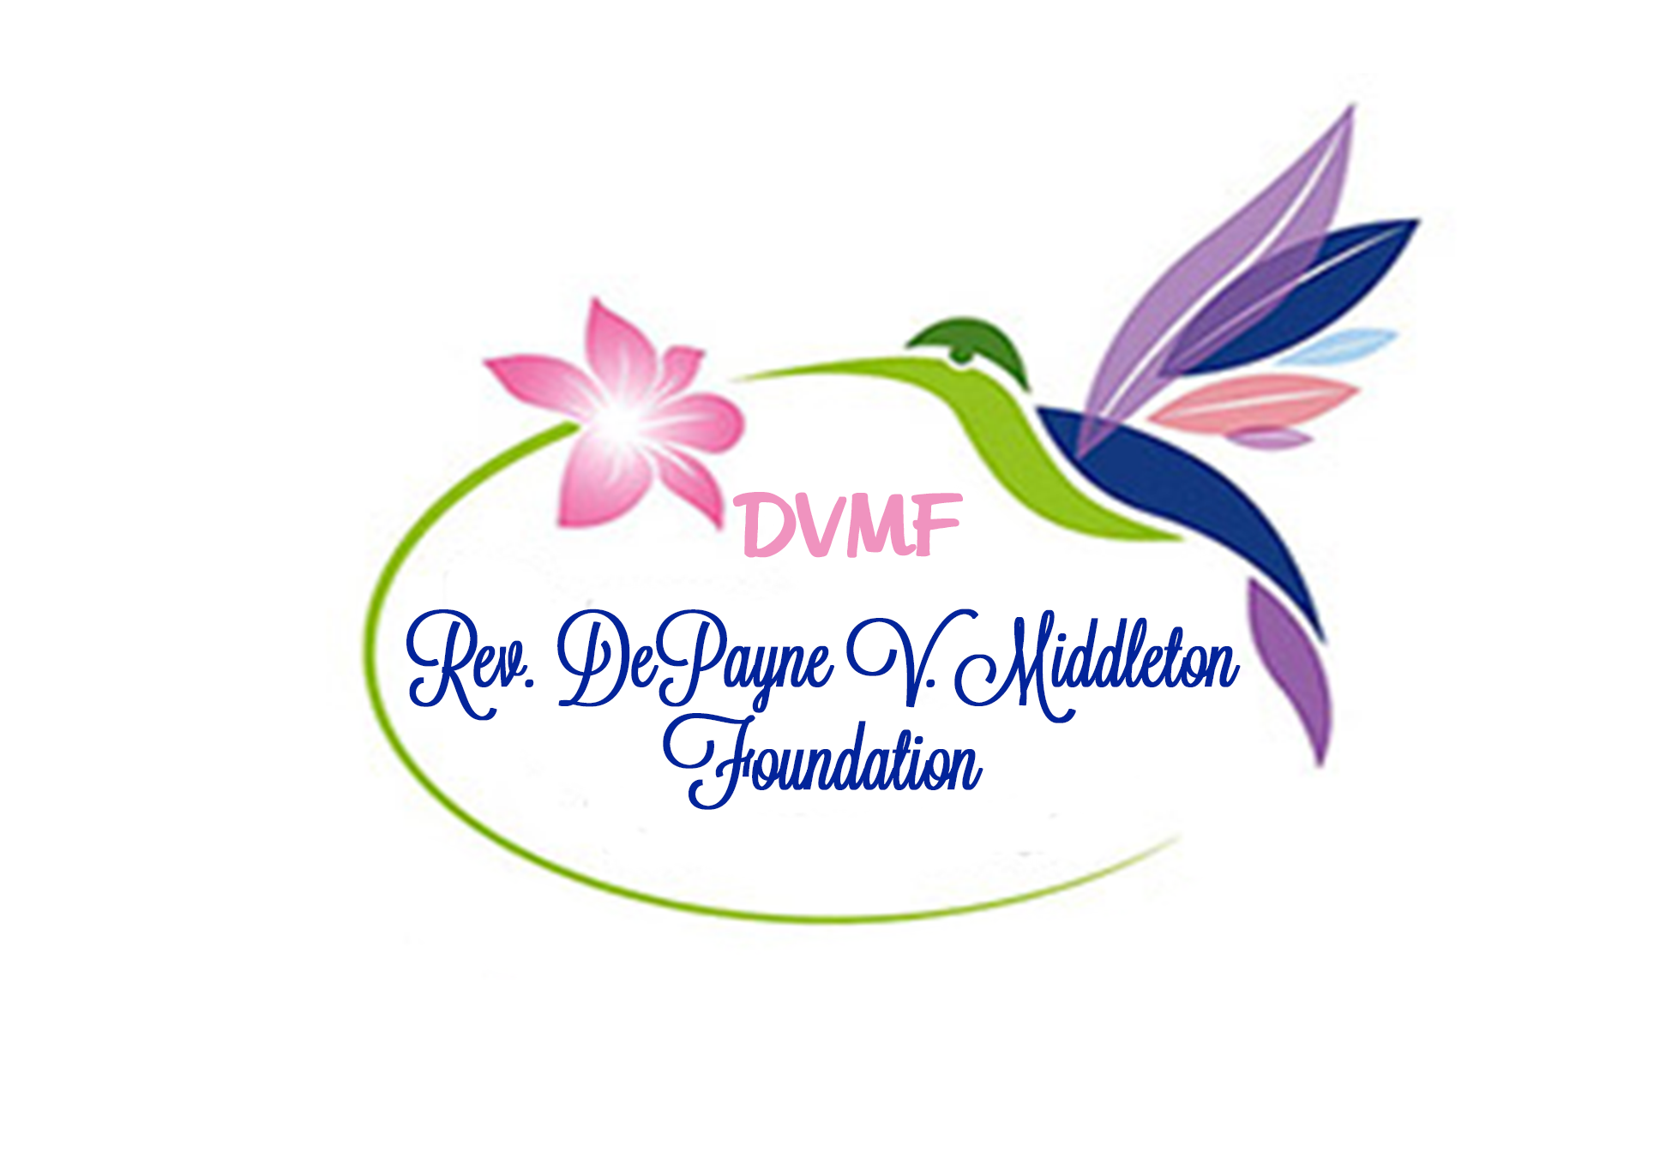
The Rev. DePayne V. Middleton Foundation announces the 2019 Rev. DePayne V. Middleton Scholarship. Two $500 scholarships will be awarded to female seniors attending high school in Charleston County, SC.

The Rev. DePayne V. Middleton Foundation
4740 Lewis & Clark Trail
Summerville, SC 29485
843-879-9166
virtuoushummingbird@gmail.com
www.thedepaynevmiddleton.com

Board Members

Ashland Temoney

Bethane Middleton-Brown

Gracyn Doctor

Archie Temoney

Alicia Kokkinis

Karen Williams

Bridget Berry

Kaylin Doctor

Margaret Cochran

Jillian Brown

Latrice Smalls

Kevin Smith

Rodero Jones

Catherine Middleton

Rene Dukes

Program Guidelines & Priorities:
* Graduating female seniors with a record of volunteerism in the community in non-school sponsored activities and participation in extracurricular activities.
*Applicants must plan to attend a two-year or four-year college or university.
*Scholarship funds will be provided in August 2019 directly to the college, not the student. The scholarship funds will be issued to the college or university upon receiving a certificate of enrollment for the fall semester.
*Applicants must have the endorsement of their school counselor on their application attesting they are eligible for this scholarship program.
Mail completed application package by May 1, 2019 to:
Rev. DePayne V. Middleton Foundation
4740 Lewis and Clark Trail
Summerville, SC 29485
(This includes application with endorsement by school counselor, essay, and letter of recommendation)

The applications will be reviewed and recipients selected by the Rev. DePayne V. Middleton Scholarship Committee. The scholarships will be awarded in June 2019 during an event honoring Rev. DePayne. Invitations will be provided with more details.
Applications can be downloaded from Rev. DePayne V. Middleton Foundation website at: www.thedepaynevmiddleton.com

Please email any questions to virtuoushummingbird@gmail.com

